Drupal 7: Guide for Content Management

Contents

Getting Started 3

Content types: 4

Basic page content type: 4

Product content type: 9

News content type: 10

Employee content type: 11

Menu Structure 12

Image carousel/slider 13

Accordion 14

# Getting Started

To login visit, <http://www.gilbarco.com/us/user>

In above URL, ‘us’ can be replaced with any other region like au, ar, br, eu, mea or sea.

Once logged in, you will be able to see an administration menu (highlighted by blue box) at the top of your page.

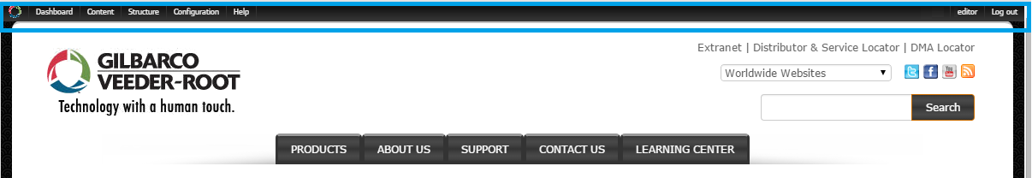

The administration menu will give you access to all functionality that your account is entitled to:

1. Dashboard: This page shows a list of recent content. At the bottom of the list, there is a ‘More’ link, which will take you to content listing page which can be used to see all available content on the site.
2. Content: This menu contains links to create new content: Basic page / News / Employee / Product.
3. Structure: Using this menu, website’s structure can be managed/changed.
4. Configurations: Please ignore this menu item as it strictly should not be played with.
5. Help: Some documentation of features and functionalities offered by Drupal

# Content types:

As an editor, following types of content have been enabled:

1. *Basic page:* Used for creating any page that does not fall under Product or News type of content
2. *Product:* Detailed content for a particular product can be created using Product content type
3. *News:* Content of type New, Event or Press Release can be created.
4. *Employee:* Create content for an employee to be featured on ‘Careers at Gilbarco Veeder-Root’ page (<http://www.gilbarco.com/us/about/careers-gilbarco-veeder-root>)

Sections below will help you how to create content of above mentioned types.

To edit any existing content, navigate to the content you would like to edit and then click on ‘Edit’ link which appears just below breadcrumbs.

## Basic page content type:

This content type can be used to create generic content. E.g. Product group pages, About Us pages, Support pages.

To create a basic page, using admin menu, navigate to: Content > Add content > Basic page

Fields:

1. *Title:* This servers as the title of the page
2. *Main image:* Hero image can be uploaded in this field. After uploading an image, ‘Alternate text’ and ‘Title’ attributes of the image can be set.
3. *Body:* Rich textual content (text/images/video) can be enter into this text area using provided editor.
   1. Text format: Below the body field, you will see a dropdown with label ‘Text format’. Use this to specify the type of content in the body field.

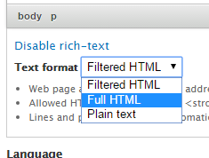

* + 1. *Filtered HTML:* This will limit the HTML tags used in body field to: <a>, <em>, <strong>, <cite>, <blockquote>, <code>, <ul>, <ol>, <li>, <dl>, <dt> and <dd>.
    2. *Full HTML:* All HTML tags, JavaScript code, CSS code will be allowed without any restrictions.
    3. *Plain text:* No HTML tags will be allowed in body field (including images & video).

It is recommended that ‘Full HTML’ should be selected since most of our content is using variety of HTML tags.

* 1. Adding/Uploading an image: To add and show an image you must first select full HTML text format.

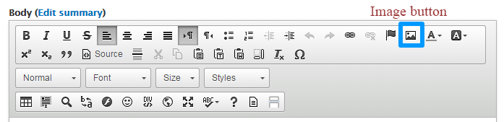

* + 1. On the editor’s toolbox, click on image button (highlighted by blue box in picture above)
    2. This will open a popup window as shown below:  
         
         
         
       Here you can either choose to:

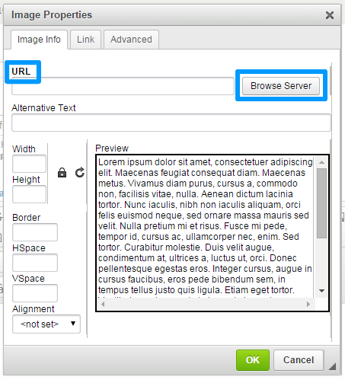

* + - 1. Directly enter the URL of an image in ‘URL’ text field. *E.g. http://example.com/test1.png*
      2. Click ‘Browse Server’ button to upload an image or select an already uploaded image. You will see another popup window as below:  
           
           
         To Upload:

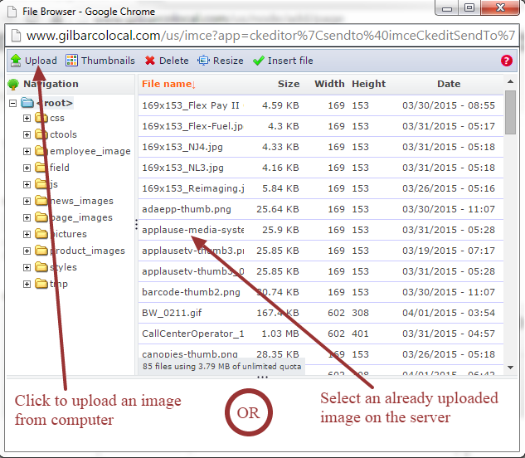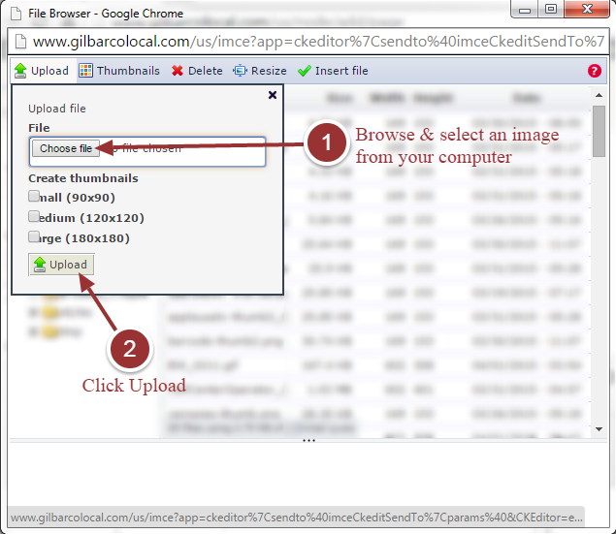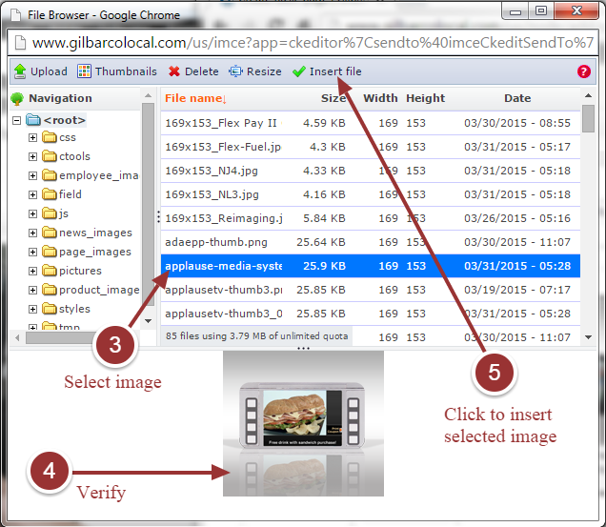

* + - 1. The selected image will appear in earlier popup window. Follow instructions in image below and click OK to insert image into editor:

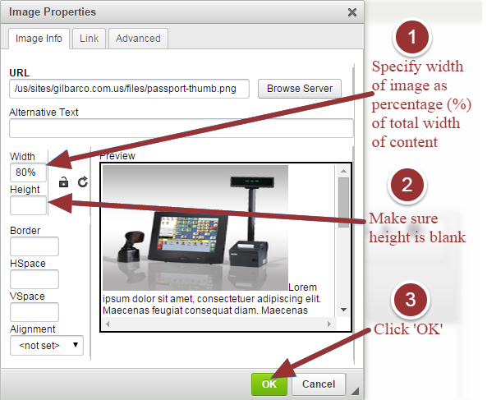

* 1. Points to remember:
     1. Regardless of how the image & text appears in the editor, actual appearance can be verified by clicking ‘Preview’ button at the end of the page.
     2. It is recommended to keep use of WYSIWYG editor for styling content to a bare minimum. This will help in keeping the style of content consistent with that of rest of the site.
     3. Only the width of an image should be specified and height field should be left blank. This helps in maintaining aspect-ration of the image when it scales as per device width.
     4. The width of an image should be specified as percentage (%) of total width of body content, as mentioned in the image above. This helps the image to scale according to device width and maintain responsiveness of the layout.
     5. If at all it is required to specify the width of an image in pixels (px), such width should not be more than 300px.

1. *Language*: Select the language of the content. This should default to ‘English’.
2. *CSS only*: This field is intended for a very specific purpose. As you might be aware of, the hero images are hidden on small screen. Below steps should be followed to enable/show hero image on small screen.
   1. Select ‘Full HTML’ text format
   2. Click on ‘Disable rich-text’
   3. Enter below code in ‘CSS only’ textarea:

|  |
| --- |
| <style type**="text/css">**  **@**media(max-width: 991px)**{**div**.**field-type-image**{display:block!important;}}**  </style**>** |

1. *Menu settings*: In order to link this page to left navigation menu, so that it has a way to be navigated to, a menu link can be created as below:  
   *Important: The menu structure is used to display breadcrumbs correctly.*
   1. Click on ‘Menu settings’ tab
   2. Check ‘Provide a menu link’ checkbox
   3. Fill ‘Menu link title’: used to give the menu link a name, which is mostly same as title of the page
   4. Using ‘Parent item’ dropdown, select an existing menu link under which the link to current page should appear.
   5. Weight dropdown can be used to specify the heaviness of the menu item which is used to set the position of a menu link under its parent i.e. among sibling menu links. Higher the number, lower the position of menu link
   6. After you create a menu link: We have two menus on the site; one for navigation on small screen and other for large screen. If the menu item is not showing in these menus, make sure the selected parent element has ‘Expanded’ checkbox checked as described in steps below:
      1. Structure > Menus > Main menu
      2. Search for the menu link you created using menu title
      3. Check the ‘Expanded’ checkbox next to the menu link of its parent menu item
      4. Click ‘Save configuration’ at the bottom of the page
2. *Meta* *tags*: The fields under this section are used for SEO purpose and can be accessed by clicking on ‘Meta tags’ tab. It is recommended to fill ‘Page title’, ‘Description’ and ‘Keyword’ fields. The description/purpose of every field is mentioned below each field. Please note that default values for page title and description fields are specified via tokens/placeholders as show in image below.

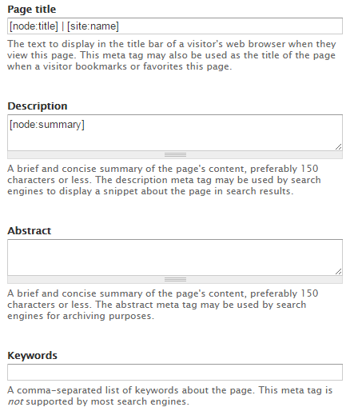

1. *URL* *path* *settings*: This tab provides a feature to set URL for current page. By default, an automatic URL will be generated having structure ‘content/<title-of-the-page>’. This is a path relative to base URL of the site (e.g. <http://www.gilbarco.com/us/> is a base URL). If you would like to manually set URL, uncheck ‘Generate automatic URL alias’ checkbox and enter a path relative to base URL of the site in URL alias textfield. For example, if you like a page in Gilbarco US website to have URL like ‘http://www.gilbarco.com/us/example1/example2’ then enter ‘example1/example2’ in URL alias textfield.

## Product content type:

This content type is used to create product content only.

To create product page, using admin menu, navigate to: Content > Add content > Product

Fields:

1. *Title*: Name of the product should be specified in this field
2. *Image*: Picture of the product can be uploaded in this field. After uploading an image, ‘Alternate text’ and ‘Title’ attributes of the image can be set.
3. *Body*: Rich textual content (text/images/video) can be enter into this text area using provided editor. For details, refer section #3 of basic page content type.
4. *Language*: Select the language of the content. This should default to ‘English’.
5. *CSS* *only*: Refer section #5 of basic page content type.
6. *Menu* *settings*: In order to link this page to left navigation menu, so that it has a way to be navigated to, a menu link can be created as described in section #6 of basic page content type.  
   *Important: The menu structure is used to display breadcrumbs correctly.*
7. *Meta* *tags*: Refer section #7 of basic page content type.
8. *URL* *path* *settings*: This tab provides a feature to set URL for current page. By default, an automatic URL will be generated having structure ‘products/<title-of-the-page>’. Refer section #8 of basic page content type for details.

## News content type:

This content type is used to create content of type News, Event & Press Release.

To create a news/event/press-release page, using admin menu, navigate to: Content > Add content > Product

Fields:

1. *Title*: Title of the article.
2. *Subtitle*: A short, single-line sub-title can be entered in this field.
3. *Language*: Select the language of the content. This should default to ‘English’.
4. *Type*: Select the category of news article: News/Event/Press release.
5. *Post* *Date*: The date on which article is posted on. Apart from display, this date is also used for sorting/ordering purpose.
6. *Image*: An image of dimension 200 x 170 pixels can be uploaded. This field is primarily used in press release content.
7. *Body*: Rich textual content (text/images/video) can be enter into this text area using provided editor. For details, refer section #3 of basic page content type.
8. *Menu* *settings*: In order to link this page to left navigation menu, so that it has a way to be navigated to, a menu link can be created as described in section #6 of basic page content type.   
   *Important: The menu structure is used to display breadcrumbs correctly. In case of press-release article, it should be noted that its link does not show in left-navigation. Menu links of press-releases should be hidden manually else they will appear in left navigation. Hence, to hide a menu link, follow below mentioned steps after saving/creating content:* 
   1. Navigate to: Structure > Menus > News
   2. Search for title of press-release article
   3. Uncheck corresponding ‘Enabled’ checkbox
   4. Click ‘Save configuration’
9. *Meta* *tags*: Refer section #7 of basic page content type.
10. *URL* *path* *settings*: This tab provides a feature to set URL for current page. By default, an automatic URL will be generated having structure ‘news/<title-of-the-page>’. Refer section #8 of basic page content type for details.

## Employee content type:

This content type is used to create testimonial content for an employee to be featured on ‘[Careers at Gilbarco Veeder-Root](http://www.gilbarco.com/us/about/careers-gilbarco-veeder-root)’ page.

To create an employee content, using admin menu, navigate to: Content > Add content > Employee

Fields:

1. *Name*: Full name of the employee
2. *Language*: Select the language of the content. This should default to ‘English’.
3. *Position*: Role or Designation of the employee in the organization.
4. *Photo*: Profile picture of the employee (80 x 80 pixels)
5. *Testimony*: A short paragraph on employee’s experience at Gilbarco Veeder-Root. For details, refer section #3 of basic page content type.
6. *Rank*: Enter an integer value used for ordering the testimony display on ‘[Careers at Gilbarco Veeder-Root](http://www.gilbarco.com/us/about/careers-gilbarco-veeder-root)’ page. Higher value will appear in the left of list, lower in the right.
7. *Meta* *tags (optional)*: Refer section #7 of basic page content type.
8. *URL* *path* *settings (optional)*: This tab provides a feature to set URL for current page. By default, an automatic URL will be generated having structure ‘employee/<title-of-the-page>’. Refer section #8 of basic page content type for details.

# Menu Structure

To configure menu structure navigate to: Structure > Menus. List of menus currently in use:

1. Main menu
2. News
3. Footer links

# Image carousel/slider

An image carousel or image slider allows you to provide a view where one can cycle through a list of images. It is possible to implement such functionality in body/description field of content. Follow bellow steps for the same:

1. Make sure text format of body field set to ‘Full HTML’. Refer section #3.1 of basic page content type.
2. Click on ‘Disable rich-text’ and add below HTML structure and replace the <path-of-image> placeholder with actual image paths

|  |
| --- |
| <div class=**"bootstrap-carousel-wrapper"**>  <div id=**"bootstrap-carousel-1"** class=**"carousel slide"** data-interval=**"0"** data-ride=**"carousel"**>  <ol class=**"carousel-indicators"**>  <li data-target=**"#bootstrap-carousel-1"** data-slide-to=**"0"** class=**"active"**></li>  <li data-target=**"#bootstrap-carousel-1"** data-slide-to=**"1"**></li>  </ol>  <div class=**"carousel-inner"**>  <div class=**"active item"**>  <img src=**"<path-of-image>"** />  </div>  <div class=**"item"**>  <img src=**"<path-of-image>"** />  </div>  </div>  <div class=**"carousel-control left"** href=**"#bootstrap-carousel-1"** data-slide=**"prev"**>  <div class=**"glyphicon glyphicon-chevron-left"**></div>  </div>  <div class=**"carousel-control right"** href=**"#bootstrap-carousel-1"** data-slide=**"next"**>  <div class=**"glyphicon glyphicon-chevron-right"**></div>  </div>  </div>  </div> |

1. To increase/decrease the number of images, add/remove following elements:
   1. Entire <li> element inside <ol class="carousel-indicators"> element
   2. Entire <div class="item"> element inside <div class="carousel-inner"> element

# Accordion

Accordions are elements used to expand and collapse content that is broken into logical sections, much like tabs. Accordion menus or navigation are widely used on the website to manage large content and navigation lists. To use an accordion in your body/description content, follow steps listed below:

1. Make sure text format of body field set to ‘Full HTML’. Refer section #3.1 of basic page content type.
2. Click on ‘Disable rich-text’ and add below HTML structure in your content where you would like to place an accordion.

|  |
| --- |
| <div id=**"accordion"** class=**"panel-group bootstrap-accordion"**>  <div class=**"panel panel-default"**>  <div class=**"panel-heading"**>  <h4 class=**"panel-title"**>  <a data-toggle=**"collapse"** data-parent=**"#accordion"** href=**"#collapseOne"**>**1. What is One?**</a>  </h4>  </div>  <div id=**"collapseOne"** class=**"panel-collapse collapse"**>  <div class=**"panel-body"**>  <p>**One is a the lowest cardinal number.**</p>  </div>  </div>  </div>  <div class=**"panel panel-default"**>  <div class=**"panel-heading"**>  <h4 class=**"panel-title"**>  <a data-toggle=**"collapse"** data-parent=**"#accordion"** href=**"#collapseTwo"**>**2. What is Two?**</a>  </h4>  </div>  <div id=**"collapseTwo"** class=**"panel-collapse collapse in"**>  <div class=**"panel-body"**>  <p>**Two represents a number equivalent to the sum of one and one**</p>  </div>  </div>  </div>  </div> |

1. The output of the above code should look as shown in below image:

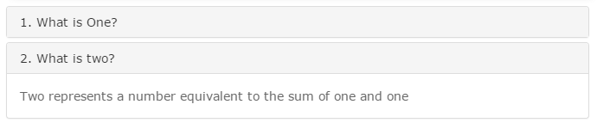

1. As you can see, in the above code ‘1. What is One?’ & ‘2. What is Two?’ are the titles/tabs of the accordion. The content within “<div class=**"panel-body"**>....</div>” is the tab’s content.
2. To increase the number of accordion tabs, duplicate the entire structure shown below:

|  |
| --- |
| <div class=**"panel panel-default"**>  <div class=**"panel-heading"**>  <h4 class=**"panel-title"**>  <a data-toggle=**"collapse"** data-parent=**"#accordion"** href=**"#collapseOne"**>**1. What is One?**</a>  </h4>  </div>  <div id=**"collapseOne"** class=**"panel-collapse collapse"**>  <div class=**"panel-body"**>  <p>**One is a the lowest cardinal number.**</p>  </div>  </div>  </div> |

1. Note that while adding new tabs to accordion, you will have to change ‘**collapseOne**’ for each tab at both positions highlighted in above code. This is required since clicking on the tab will help focus its corresponding content & also because the value of an ‘id’ attribute is unique on for entire page. E.g. *collapseThree*, *collapseFour* and so on.